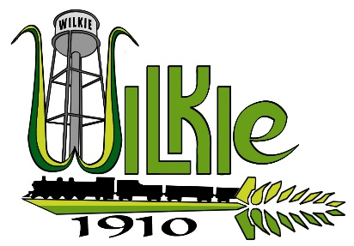
FOR SALE
Commercial Property
503 7th Avenue West - Lots A, B & C, Block 71

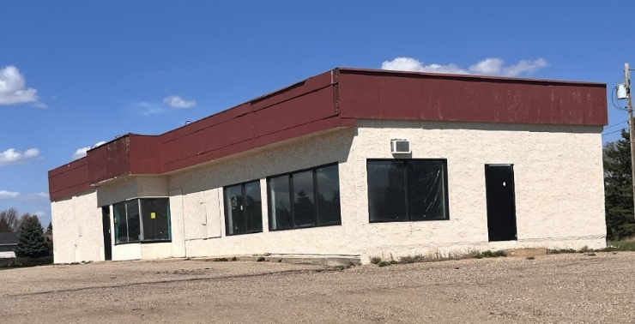

The property built in 1961 for sale in the Town of Wilkie. The property contains 1 building which is currently in a dilapidated state. The site has an environmental impact from previous usage.

Interested persons shall contact the undersigned for an Invitation to Tender Package and an Expression of Interest and Confidentiality Agreement prior to submitting an offer and or/ receiving an information package including 1) the most recent tax certificate, 2) a recent SAMA assessment and/or, 3) a walkthrough of the Property.

TOWN OF WILKIE
Attn: Rebecca Parent
PO Box 580
Wilkie, SK S0K 4W0
Ph: (306)843-2692
Wilkie.administrator@sasktel.net

