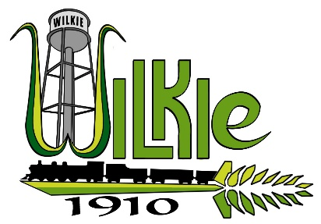
PUBLIC NOTICE TO RESIDENTS
TOWN OF WILKIE
ANNUAL WATER MAIN FLUSHING

Public Works advises that Annual Water Main Flushing will be done, weather permitting, during the hours of 7 am to 4 pm, May 12 to 16, 2025.
The flushing of the water mains is an important maintenance item that helps to clean the pipes out. Residents may experience loss of water pressure or a brief period of no water when crews are flushing in your area. When the water pressure returns, you may experience the water supply showing sediment and/or discoloration – if this happens to you, wait for a while and test your taps periodically until pressure is restored.
The sediment and/or discoloration is harmless; however, it can cause discoloration to laundry if not detected, therefore, residents are encouraged not to wash clothes or use bleach during these hours.
If you experience discolored water, run your taps until the water runs clear.

Public Works Department
Town of Wilkie

