
Swimming Pool Sponsorship Information

January 30, 2025

To whom it may concern,

As a valuable business in our community, we would like to invite your business to be a part of Wilkie’s New Swimming Pool project. The Mayor and Town Council, Wilkie Recreation Director and Rec Board, our on-site Coordinator, Town Employees and Community Volunteers have spent countless hours pouring their energy into this project to make the New Swimming Pool a reality.
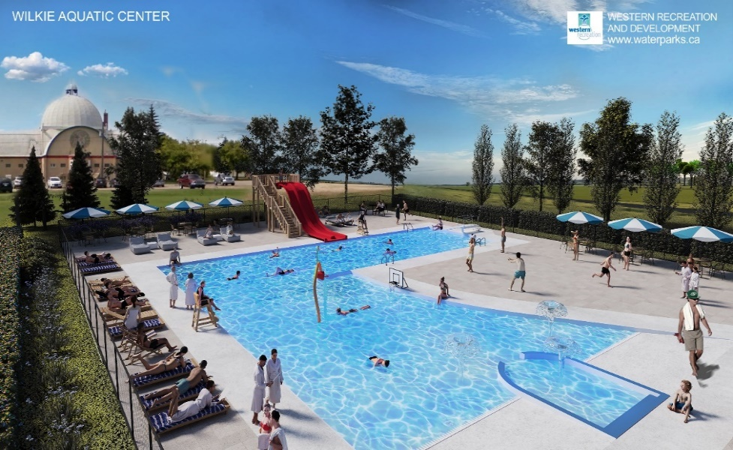
Construction began in August 2024 on Wilkie’s New Swimming Pool project consisting of a 4,000 ft² change house building and the swimming pool basin featuring a walk-in entry, tot pool, pro-racer water slide and a ¾ meter diving board.
The New Swimming Pool is expected to be completed in summer 2025 and the Town is looking forward to the Grand Opening!

COSTS & FUNDING

Funding Facts
- This $3.22 million project is funded primarily by various grants.

- As of Dec 2024, we have received 60+ Bonze Sponsors, 20 Silver Sponsors,
2 Gold Sponsors, 1 Platinum Sponsor and 1 Diamond Sponsor!

- All sponsors will be recognized on a sponsor wall at the new pool.

$3,220,000 Goal

$244,000 Fundraising &
Donations

$2,430,000 Grant Funding

SPONSORSHIP
Diamond $15,000 – $25,000
Platinum $10,000 – $14,999
Gold $5,000 – $9,999
Silver $1,000 – $4,999
Bronze $20 – $999

If your business would like to be a part of this amazing new project, please consider donating today. We appreciate every donation and want to ensure recognition is given to all sponsors. We have set the different levels of sponsorship in this chart to suit the needs of everyone.

If you are wanting to be a Diamond Level Sponsor but want your company name on something more then the plaque??? There are numerous areas and items that can be sponsored separately and sponsorship will be recognized on the space or item individually as well as on the sponsor board.

NAMING RIGHTS

Does your organization want to show your commitment to the community in a more substantial way?
The Town of Wilkie is accepting proposals for naming rights to the New Swimming Pool!
We are excited to partner with the right business and give you the opportunity to put your business name on the new pool change house by donating on a larger scale. We request that proposals be for a minimum of
5-year term. The deadline for proposals is February 28, 2025.
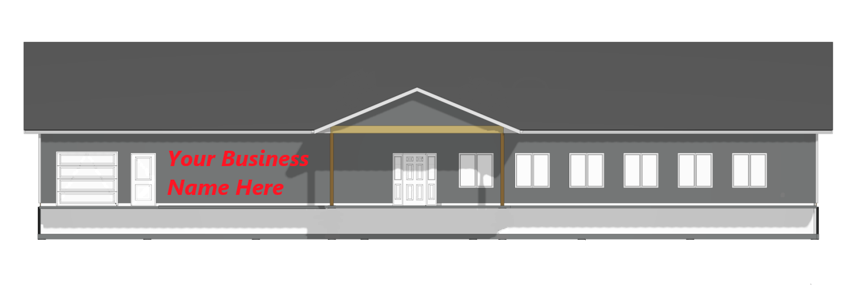
Council representatives would be happy to arrange a meeting with you and would love to discuss sponsorship further with your business! If this interests your organization or for more information, contact Lori at the Town Office as below. We appreciate your consideration and look forward to connecting with you.
Lori Fenrich, Recreation Director – 306-843-2692 – wilkierecreation@sasktel.net

