
FOR SALE BY TENDER
Commercial Property
110 2nd Avenue East - Lot 7, Block 9
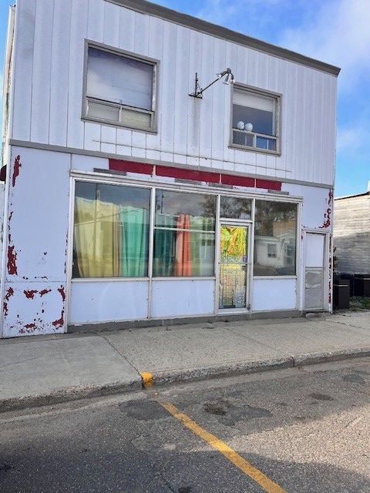
Tenders must include corporate/personal legal name,
address, phone number and email address.

All tenders to be accompanied by a certified cheque for five
percent (5%) of the total tender value.

Minimum bid is $10,454.66; bids lower than minimum
will be rejected; highest or any offer not necessarily
accepted. Deliver all offers on or before 3:00 PM on the
4th of December, 2025.

Successful bidder will have thirty days from acceptance to complete any building inspection, environmental inspection, or other inspection desirable to the purchaser.

The property built in 1911 for sale in the Town of Wilkie. Property had additions in 1933, 1955 and 1965 and is 1,352 sq. ft. on main floor and has a living area upstairs.

Interested bidders shall contact the undersigned for an Invitation to Tender Package and an Expression of Interest and Confidentiality Agreement prior to bidding and or/ receiving an information package including 1) the most recent tax certificate, 2) a recent SAMA assessment and/or, 3) a walkthrough of the Property.

TOWN OF WILKIE
Attn: Rebecca Parent
PO Box 580
Wilkie, SK S0K 4W0
Ph: (306)843-2692
Wilkie.administrator@sasktel.net

