***FOR SALE***

***Residential Property – 936 sq. foot House***

***406 1st avenue – Lots 5 &6, Block 31***

Residential Property with a house built in 1930 for sale in the Town of Wilkie. The interior is full of junk and would require major cleaning. The purchaser buys the property “as is” and is responsible for clean-up and all future repairs and costs.

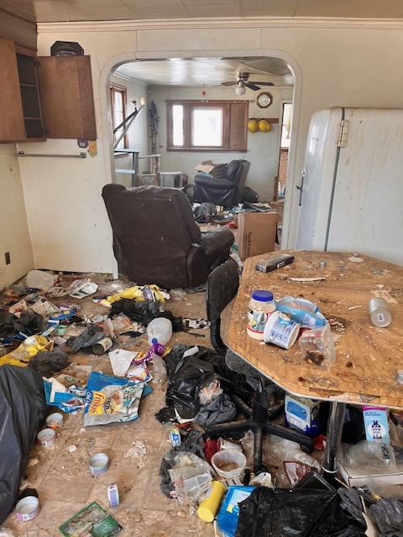

For more information or to view the property, contact Rebecca Parent at the Town office at 306-843-2692, [wilkie.administrator@sasktel.net](mailto:wilkie.administrator@sasktel.net)

Offers can be submitted to Rebecca Parent, CAO at the Town of Wilkie office, PO Box 580, Wilkie, SK S0K 4W0 or wilkie.administrator@sasktel.net

*Rebecca Parent, CAO*

*Town of Wilkie*