
FOR SALE BY TENDER
Residential Property – 816 sq. foot House
302 3rd Street West – Lot 16, Block 13

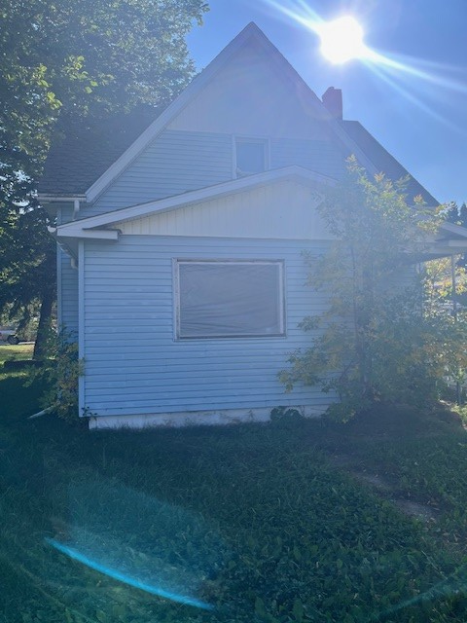
Residential Property with a house built in 1918 for sale in the Town of Wilkie. The purchaser buys the property “as is” and is responsible for clean-up and all future repairs and costs.

For more information or to view the property, contact Rebecca Parent at the Town office at 306-843-2692 or wilkie.administrator@sasktel.net
Minimum bid is $6,959.37; bids less than minimum will be rejected.
Bids must be submitted by December 4th, 2025 @ 3:00 p.m. to:
Vantage Chartered Professional Accountants
c/o Austin Odnokon
PO Box 970, North Battleford, SK S9A 3V4.

Rebecca Parent, CAO
Town of Wilkie

