
FOR SALE
Residential Property – 816 sq. foot House
302 3rd Street West – Lot 16, Block 13

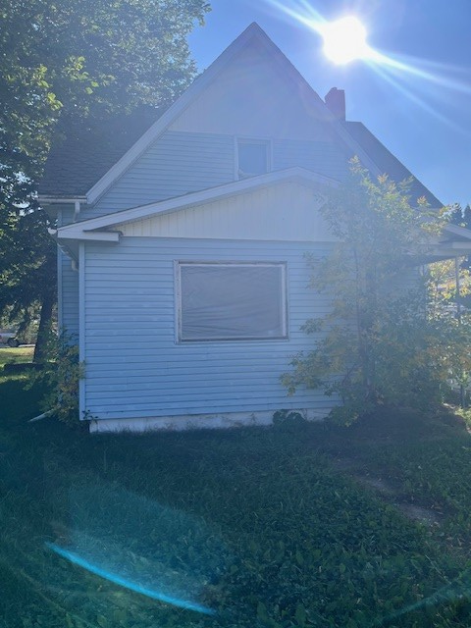
Residential Property with a house built in 1918 for sale in the Town of Wilkie. The purchaser buys the property “as is” and is responsible for clean-up and all future repairs and costs.

Offers are accepted at the Town office to:
Town of Wilkie
Attn: Rebecca Parent
PO Box 580
Wilkie, SK S0K 4W0
Wilkie.administrator@sasktel.net

